**Database Practical Week 5**

Practical 5

INDADD 2015/2016  
Introduction to Database Analysis and Design  
School of Computing  
Week 5 Practical 5  
ERD Part I

Top of Form

Part I: Coursework

Please read the coursework CE, available on Moodle under "assessment". In your own time and before the next tutorial, do the following: 1- Identify the main entities 2-Identify the relations between the entities in step 1.

Part II: Relationships

**1. In the University of Portsmouth, each course contains many students, but each student can register in one course only. Which of the following represent this relationship:**

* +  Student     1   -----------------   1     Course
  +  Student     *   -----------------   1     Course
  +  Student     1   -----------------   *     Course
  +  Course      *   -----------------   1     Student

1. **Discuss a way in which the 1:* relationship between STUDENT and COURSE can be implemented.**

When creating the two tables, the relationship can be shown through the connection of the primary and foreign keys within each table. For example, each course will have a unique id such as UNIT01 and each student will have a column called COURSE where UNIT01 could be displayed in that column. This would link the two together. In this way many student tables can have the same primary key in their COURSE column.Bottom of Form

**3. Suppose you are using the database composed of the two tables shown in the following figures**

a. Identify the primary keys.

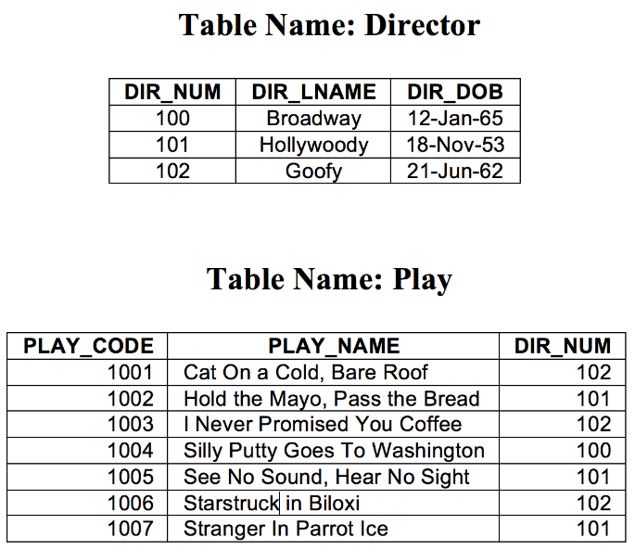

DIR_NUM

PLAY_CODE

b. Identify the foreign keys.

DIR_NUM

c. In your log book, create a ERD for the tables.



1. **Suppose that you have the relational model shown in the figure below. How would you convert this model into a model that displays only 1:* relationships? (Make sure that you draw the revised models in your log book)**

To remove the many to many relationship we would create a new composite entity (new table) where we can store the primary keys for both the DRIVER and TRUCK entities. This will create 2 seperate 1 to many relationships connecting to one table.



## Scenarios (from week 4)

For each business rule you have identified in the tutorial last week (week 3),

1. draw the relationships between the entities. For example: Division 1 ------------ * Departments 2. For each entity define appropriate set of attributes

3. Resolve any * to * relationship.

**Scenario 1**

Each of the MegaCo Corporation’s divisions is composed of many departments. Each of those departments has many employees assigned to it, but each employee works for only one department. Each department is managed by one employee, and each of those managers can manage only one department at a time.

MegaCo has many divisions

Each division is composed of many departments

Each department is run by one manager

Each department has many employees

Only one manager can run one department

Each employee can only work for one department

DIVISIONS should have a DivsionId

DEPARTMENTS should have a DepartmentId

MANAGERS should have a ManagerId

EMPLOYEES should have a EmployeeId

DEPARTMENTS should have a foreign key of DivisionId

MANAGERS should have a foreign key of DepartmentId

EMPLOYEES should have two foreign keys of ManagerId and DepartmentId

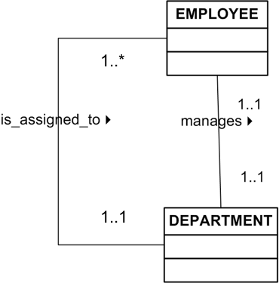

**Senario 2**

The KwikTite Corporation operates many factories. Each factory is located in a region. Each region can be “home” to many of KwikTite’s factories. Each factory employs many employees, but each of those employees is employed by only one factory.

KwikTite runs many factories.

Each factory is in a certain region

One region can have many factories

Each factory employees many employees

Each employee is assigned to only one factory

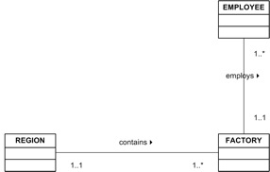

**Senario 3**

The Hudson Engineering Group (HEG) has contacted you to create a conceptual model whose application will meet the expected database requirements for the company’s training program. The HEG administrator gives you the description (see below) of the training group’s operating environment: The HEG has 12 instructors and can handle up to 30 trainees per class. HEG offers five “advanced technology” courses, each of which may generate several classes. Each class is taught by one instructor. Each instructor may teach up to two classes or may be assigned to do research only. Each trainee may take up to two classes per year.

HEG has 12 instructors

Each instructor can handle 30 trainees per class

HEG has five different courses

Each course has many classes

Each class is taught by one instructor

Each instructor can teach up to two classes or can be assigned to research instead

Each trainee can take, up to, two classes per year

COURSE should have a CourseId

CLASS should have a ClassId

INSTRUCTOR should have InstructorId

TRAINEE should have TraineeId

We have to make a new entity called ClassTrainee

ClassTrainee should have a composite key of ClassId and TraineeId

CLASS should have a foreign key of CourseId

INSTRUCTOR should have a foreign key of ClassId

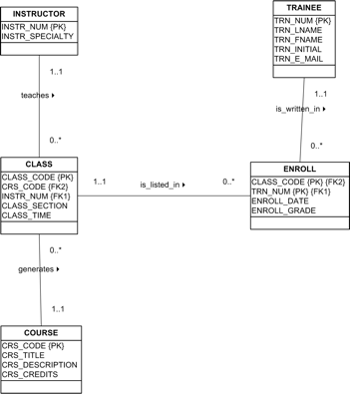

## Extra Scenarios

In your own time, for each of the following scenarios, define appropriate attributes for each entity, create the appropriate ERD using UML notation in your log book. Resolve any * to * relationship.

## Senario 5

1. A football team has at least 11 players and may have up to 40 players. b. Each player may or may not play one or more games. c. A minimum of 11 players and a maximum of 14 players may participate in one game. d. A player may or may not score one or more goals. e. Each game may have zero or more goals.
2. 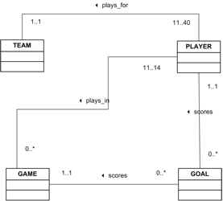

## Senario 6

a. A musician makes at least one recording, but may over a period of time make many recordings. b. One recording consists if at least 3 or more tracks. c. A track can appear on more than one recording.

